Computer languages

Computer language is a formal system used to communicate with computers. It allows humans to give instructions, define data, and control how a computer behaves. Think of it as the bridge between human logic and machine execution.

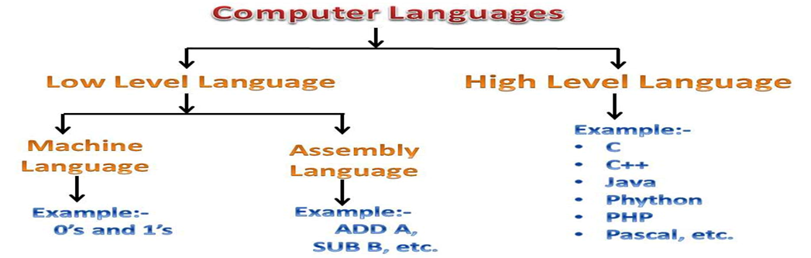

1. Low-Level Languages

• Machine Language: Binary code (0s and 1s) directly understood by the computer.

• Assembly Language: Uses symbol codes and requires an assembler to convert to machine code.

2. High-Level Languages

• Programming Languages: Used to write software and applications. Examples: Python, Java, C++, JavaScript

• Markup Languages: Used to structure and present data.

Examples: HTML, XML

• Query Languages: Used to retrieve data from databases.

Example: SQL

• stylesheet Languages: Define how content looks. Example: CSS

Describe Python language 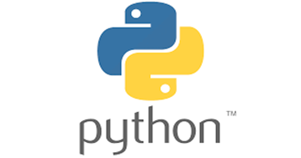

Python is a high-level, general-purpose programming language used to write software, analyze data, build websites, automate tasks, and much more. It’s known for its simple syntax, which makes it easy to learn and powerful to use—even for beginners.

Key Characteristics

* **Interpreted:** Python code is executed directly by an interpreter, which translates it into machine code, eliminating the need for a separate compilation step.
* **High-level:** Python abstracts away many low-level details, allowing developers to focus on the problem at hand rather than memory management or hardware specifics.
* **Object-Oriented:** It supports object-oriented programming principles, which help organize code into reusable components called objects.
* **Readable Syntax:** Python's syntax uses white space to define code blocks, making it clear, less cluttered, and easier to read and maintain.
* **General-Purpose:** Python is not specialized for one domain, but rather can be used for a wide variety of applications, from web applications to data analysis.

Common Uses

* [**Web Development**](https://www.google.com/search?sca_esv=8fb985a9e177f272&rlz=1C1CHBD_enIN1138IN1152&biw=1812&bih=854&q=Web+Development&sa=X&ved=2ahUKEwidvabZ-tyPAxU5dvUHHVTeLcsQxccNegUI7wEQAQ&mstk=AUtExfDrUO38wElf2AXWjNeJmNxLizjNceUOFsBWsIKL-yWkwB8YwYhV_HTnywR_xfzRRoruWUrdH0rLfpiuzSLqhxLWtXfDSdiL447kMJ9pDqHcjRFTjMHcYQMJoEGlnyFBSMc&csui=3)**:** Building websites and web applications.
* [**Data Science**](https://www.google.com/search?sca_esv=8fb985a9e177f272&rlz=1C1CHBD_enIN1138IN1152&biw=1812&bih=854&q=Data+Science&sa=X&ved=2ahUKEwidvabZ-tyPAxU5dvUHHVTeLcsQxccNegUI8AEQAQ&mstk=AUtExfDrUO38wElf2AXWjNeJmNxLizjNceUOFsBWsIKL-yWkwB8YwYhV_HTnywR_xfzRRoruWUrdH0rLfpiuzSLqhxLWtXfDSdiL447kMJ9pDqHcjRFTjMHcYQMJoEGlnyFBSMc&csui=3)**:** Analyzing data, performing complex mathematics, and visualizing data.
* **Machine Learning (ML) & AI:** Powering innovations in catboats, image generation, and self-driving cars.
* **Task Automation:** Automating repetitive tasks and connecting various components.
* **Software Development:** Creating a wide range of applications and system scripts.

